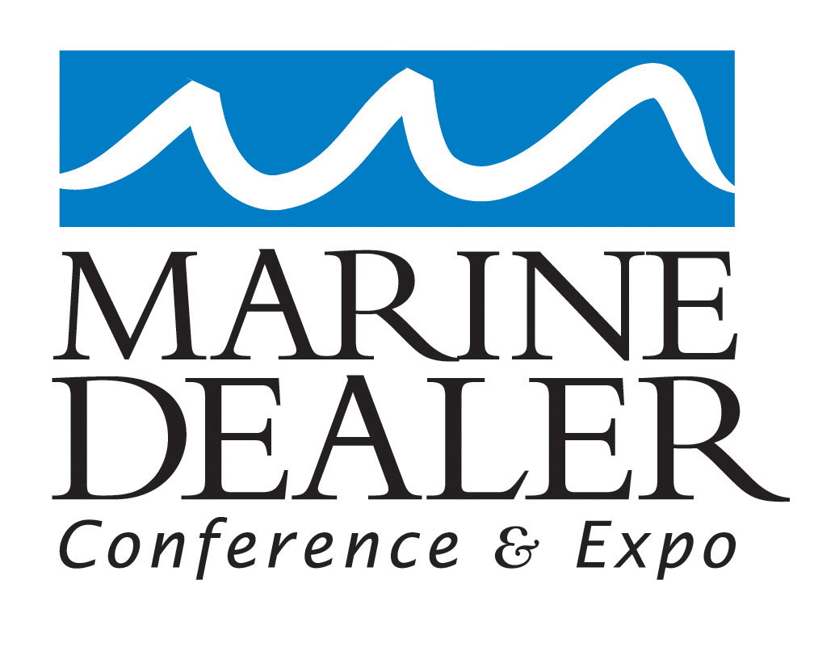

Marine Dealer Conference & Expo Request for Presentations

Name:

Title:

Company:

Working title of proposed presentation(s):

Description of presentation(s):

How many times have you presented to groups of 50 or more during the past year?

Please list three references among the groups to which you have recently presented, including the name of the group; the name, e-mail and phone number of your recommended contact; and a one-sentence summary of the topic you spoke on.

MDCE organizers ask attendees to evaluate speakers’ presentations on a scale of 1 to 5 in four areas: how well they entertained and engaged the audience; whether they were worth attendees’ time and money; whether the content was useful and practical; and whether the attendee was fully present and actively participated in the seminar. In 2012, we are aiming for an average score of 4.75 or greater. How confident are you that you can deliver such high scores in these four areas? Please explain your answer.

In order to deliver the highest quality of presentation, how much time would you consider ideal for each of the presentation concepts you are proposing?

In 2012, MDCE organizers will require each speaker to provide a handout to accompany their presentation, above and beyond the PowerPoint presentation they prepare for their session. Do you agree to prepare and submit such a handout by a deadline of September 1, if you’re chosen to present?

Please submit materials that will give MDCE organizers insight into your presentation skills, such as links to videos or DVDs of past presentations.

